

**OFFICE OF THE PRESIDENT**

**TO ; ALL CONCERNED August 15, 2020**

**SUBJECT : DATA PRIVACY COMMITTEE**

Greetings!

As approved by the School Board, we would like to inform you of the composition of the DATA PRIVACY COMMITTEE effective AY 2020-2021:

Officer - Dr. Julieta M. Catipay

Members - Atty. Mae Elaine T. Bathan

Mrs. Duint N. Lim

Atty. Ramiejella S. Viagedor

Mr. Dexter Joseph B. Cuevas

Mr. Alexander Omangay

Atty. Jesus D. Velez

Please extend to them you usual kind support and cooperation so that they can efficiently carry out the tasks assigned to them.

Thank you for your attention.

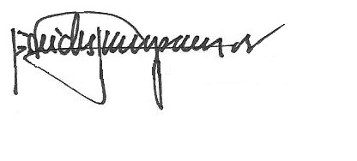

REV. FR. CRISTOPHER C. MASPARA, OAR

President

/bvs